Council for Learning Disabilities Annual Conference
San Antonio, Texas
October 3-4, 2019

Cynthia A. Dieterich, Ph.D.
Baldwin Wallace University
Cleveland, Ohio

Kathy Ewoldt, Ph.D.
University of Texas San Antonio
San Antonio, Texas

Impartial Hearing Officer
- Parents and school consider mediation
- Unresolved issues move to IHO
- Formal hearing with both sides presenting evidence
- Both parties can have an attorney and witnesses
- IHO writes a decision based on the facts
Federal Court System
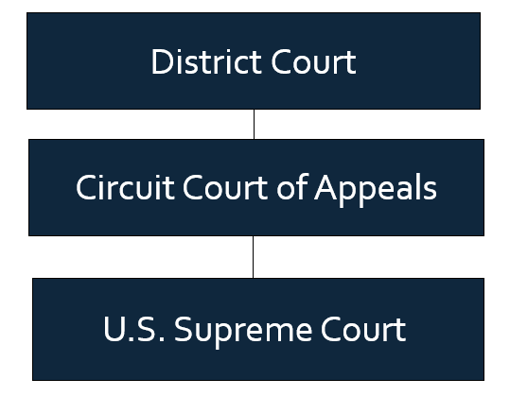

Specific Learning Disabilities: Recent Litigation Highlights
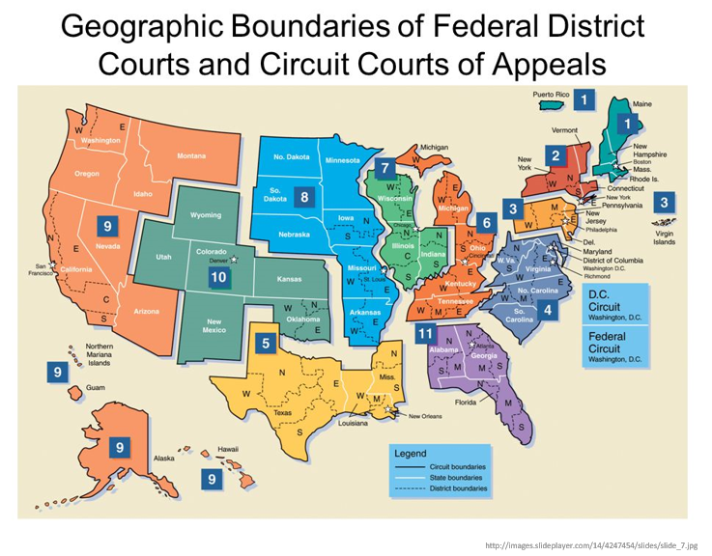

Free and appropriate public education
Blunt v. Lower Merion Sch. Dist., 767 F.3d 247 (3d Cir. 2014)
- Although some evidence African-American students overrepresented in statistical sense in special education classes.
- Each student's educational needs were assessed and satisfied through thorough and individualized process.

Durbrow v. Cobb Cty. Sch. Dist., 887 F.3d 1182 (11th Cir. 2018)
- Student successful elementary through junior year of high school.
- His academic performance plummeted senior year
- He submitted numerous late and incomplete work throughout the year.
- District court concluded that he was entitled to neither an IDEA evaluation nor special education because he did not qualify as a "child with a disability."
T.B. v. Prince George's Cty. Bd. of Educ., 897 F.3d 566 (4th Cir. 2018)
- Student’s declining grades reflected declining attendance and disruptive nature in class.
- When student attended class, completed assignments—student performed adequately
- Therefore not the school district’s procedural violations of not providing an evaluation, but the student’s own actions that prevented the student from receiving a FAPE,
- Student could not recover under the IDEA
McLean v. District of Columbia, 264 F. Supp. 3d 180 (D.D.C. 2017)
- Eligibility intertwined with procedural FAPE.
- Claim that the district failed to comprehensively evaluate student, D.M., because evaluation did not include classroom observations or a teacher interview.
- HO ruled in favor of the school district, because D.M.’s mother had not shown that D.M.’s ADHD adversely affected his academic performance. D.M.’s mother appealed to the district court
- District court held that the hearing HO’s decision was inadequate because he took the expert witness’s testimony out of context and did not fully consider the professional opinion of the plaintiff’s experts.
- Remanded to allow the hearing officer to assess the expert’s testimony to decide whether D.M.’s ADHD was a qualifying disability under IDEA.
M.M. v. Lafayette Sch. Dist., 767 F.3d 842 (9th Cir. 2014)
- School district's failure to provide educational testing data to parents violated the procedural requirements of the IDEA
- Prevented parents from meaningful participation to create their son's IEP
- Thus denying the student a FAPE
- School district actions
  - Did not fail to properly incorporate "Response-to-Intervention" or "RTI" testing data into the student's initial evaluation.
  - However, violated the IDEA by failing to insure that the RTI data was documented and carefully considered by the entire IEP team
- Failed to furnish the parents with the data
- Thereby parents were unable give informed consent for both the initial evaluation and the special education services their son received.

Child Find
Z.J. v. Bd. of Educ. of the City of Chi., Dist. No. 299, 344 F. Supp. 3d 988 (N.D. Ill. 2018)
- District court found that the school district violated child find one month after receiving second very low standardized test score for child subsequently determined to be eligible as OHI/SLD
- However it was not at the earlier date that the parent asserted

Eligibility
Sch. Bd. Of Suffolk v. Rose, 133 F. Supp. 3d 803 (E.D. Va. 2015)
- HO determined a student was improperly identified with an ED
- Should be identified as a student with autism
- Three psychological experts delivered this opinion
- HO also concluded SPS improperly failed to inform parents that the child could no longer able attend the parents’ preferred private school if he was identified as ED.
- HO ordered SPS to delete the ED label from the Child’s educational record. District court upheld the Hearing Officer’s decision that the student should be found eligible as a child with Autism.
- Did not uphold HO’s decision that the student is not a child with an emotional disturbance.
- Court found there was more than negligible evidence to suggest the student also had characteristics of an emotional disability.
Doe v. Cape Elizabeth Sch. Dist., 832 F.3d 69 (1st Cir. 2016)
- First Circuit court ruled that the District Court should first decide whether Doe has a reading fluency deficit
- To make this determination, the court may consider Doe’s overall academic performance
  - Insofar as her generalized academic record is shown to be a fair indicator of her reading fluency deficit AND
- Results of specific reading fluency assessments.
- Student’s grades and overall school performance can be one factor considered in determining eligibility under the IDEA
- “…Grades or school performance considered must be narrowed to those components related to the student’s suspected academic or functional deficiencies” https://mcandrewslaw.com/publications-and-presentations/articles/good-grades-are-not-enough-to-support-a-finding-of-ineligibility/

Lisa M. v. Leander Indep. Sch. Dist., 924 F.3d 205 (5th Cir. 2019)
- School strict found student not eligible for special education claiming he was accessing education and making grade level progress.
- SEHO found student eligible and “shocking differences between teachers and district staff opinions.”
L. J. v Pittsburg Unified Sch. Dist., 850 F.3d 996 (9th Cir. 2017)
- School district court clearly erred in concluding that the student was performing satisfactorily, as he was in fact receiving special services, including mental health counseling and one-on-one assistance
- District court did not take into account the student’s continued troubling behavioral and academic issues
- Student’s psychiatric hospitalizations and suicide attempts were relevant to his eligibility for specialized instruction even though they occurred outside of school
- School district violated procedural safeguards of the IDEA that deprived the student’s mother of her right to informed consent.

IEP
Dunn v. Downingtown Area Sch. Dist. (In re K.D.), 904 F.3d 248 (3d Cir. 2014)
- Reviewed and revised the individualized education program (IEP) to keep them appropriately rigorous
- Court noted that IEPs must be reasonable, not ideal.

Stay-Put Provision
M.R. v. Ridley Sch. Dist., 868 F.3d 218 (3d Cir. 2017)
- Parents unilaterally placed their child in a private school
- They disagreed with the school district’s IEP
- Filed a due process complaint seeking reimbursement for private school costs
- HO ordered reimbursement
- Parental request for payment from the district was nearly two years later after district court reversed HO’s finding that the district’s proposed IEP was adequate
- Circuit court held that HO ruling validating parents’ decision to move their child from an IEP specified public school to a private school makes the child’s enrollment at the private school the then-current educational placement for the purposes of the stay-put rule
- School district’s financial obligations do not dissolve simply because the parents do not make a request for reimbursement until after HO’s ruling has been reversed by court order.

Independent Evaluation
B.G. v. Bd. of Educ., 901 F.3d 903 (7th Cir. 2018)
- District court did not abuse its discretion by denying the student's motion to supplement the record with additional Independent Educational Evaluations (IEEs) and tests
- Adding the post-hearing IEEs would likely have turned the proceedings into a trial de novo rather than a review
- HO did not err in approving the student's evaluation and plan because substantial evidence in the record supported the HO’s decision that the district's evaluations were appropriate under the governing regulations
- HO’s decision was entitled to deference and as well-supported by the record
  - Record showed a five-day hearing was comprehensive AND
  - School district's evaluators were competent, well-trained, and performed comprehensive evaluations.
Remedy
G.L. v. Ligonier Valley Sch. Dist. Auth., 802 F.3d 601 (3d Cir. 2015)
- If parents reasonably do not discover the denial of their child’s FAPE for many years;
- As long as parents file within two years of discovering it;
- Parents have no limit on the number of years for which they can seek relief
Seth B. v. Orleans Parish Sch. Bd., 810 F.3d 961 (5th Cir.2016)
- Parents seek reimbursement $8000 for Individual Education Evaluation of a child with a suspected learning disability.
- Vacated and remanded to lower courts
- If lower court finds IEE substantially compliant, then reimbursement. If reimbursement, it is limited to the $3000 cap.
- Part of the issue is that state evaluations have certain criteria; private evaluations do not. So, forcing a state to pay for an evaluation it will not consider unnecessarily drains scarce resources – as pointed out by dissenting judge
H.E. v. Walter D. Palmer Leadership Learning Partners Charter Sch., 873 F.3d 406 (3d. Cir. 2017)
- HO dismissed parents’ case
- Held that parents could not go after PADOE
- Relief through the charter school’s settlement claims process.
- Parents filed in district court seeking reversal HO’s decision plus attorney’s fees and costs. “The federal court vacated the HO’s decision
- Remanded to HO on the issue of compensatory education
  - But denied the parents’ claim for attorney’s fees because it was a victory on purely procedural matters, not a substantive claim, and therefor they were not prevailing parties.
- Third Circuit reversed the district court on that basis and said that parents were indeed prevailing parties and entitled to reimbursement of their attorney’s fees and costs.
Lejeune v. Khepera Charter Sch., 327 F. Supp. 3d 785 (E.D. Pa. 2018)
- SEA is not required to step in when a charter school is unwilling to comply with its settlement obligations.
- When a charter is not defunct but unable to comply, the SEA has “significant discretion” in deciding how to fill the charter’s shoes, even where that discretion changes the terms of an existing settlement agreement.
- SEA was not held responsible for fees required by a settlement agreement where it was not a party to the underlying dispute that resulted in the settlement.
Endrew F. v. Douglas County School District (2017)
- Endrew is the legal test
- Recognizing not maximize student potential
- Post-Endrew standard that an educational program must be appropriately ambitious with goals that may differ between students, yet provide the students the opportunity to meet challenging objectives
- Post-Endrew F. impact of the new FAPE standard to provide an educational program that is reasonably calculated to enable a student to make appropriate progress in light of the student’s circumstances

